The Circle of Fifths

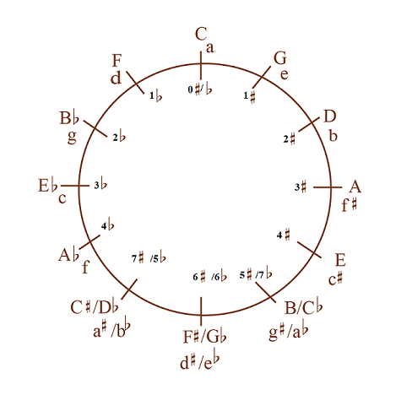

Find your key using the circle of fifths:
- For Bb instruments: move two places to the right of concert key (ex. Bb = C).
- For Eb instruments: move three places to the right of concert key (ex. Bb = G).
- For F instruments: move one place to the right of concert key (ex. Bb = F).

Order of Sharps: Father Charles Goes Down And Ends Battle
Order of Flats: Battle Ends And Down Goes Charles’ Father

